I
n this session we will look at what is error event and how it functions ?.

A BPMN error is meant for business errors - which are different than technical exceptions. So, this is different than Java exceptions - which are, by default, handled in their own way.

Error event types:
According to what was explained in the previous section, these are the available Error Event types.

Camunda Error Event
- Start Error Event.
- Error Boundary Event
- End Event Event

Start error event
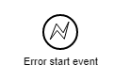
An error start event can only be used to trigger an Event Sub-Process - it cannot be used to start a process instance. The error start event is always interrupting.

Note: We will perform exercise for start error event in event based sub process.

Error End event:
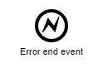
When process execution arrives at an error end event, the current path of execution is ended and an error is thrown. This error can be caught by a matching intermediate error boundary event. In case no matching error boundary event is found, the execution semantics defaults to the none end event semantics.

Intermediate error boundary event
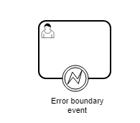
An intermediate catching error event on the boundary of an activity, or error boundary event for short, catches errors that are thrown within the scope of the activity on which it is defined.
Defining an error boundary event makes most sense on an embedded subprocess, or a call activity, as a subprocess creates a scope for all activities inside the subprocess. Errors are thrown by error end events. Such an error will propagate its parent scopes upwards until a scope is found on which an error boundary event is defined that matches the error event definition.
When an error event is caught, the activity on which the boundary event is defined is destroyed, also destroying all current executions therein (e.g., concurrent activities, nested subprocesses, etc.). Process execution continues following the outgoing sequence flow of the boundary event.
1. We will model following process to demonstrate boundary error and end error event.
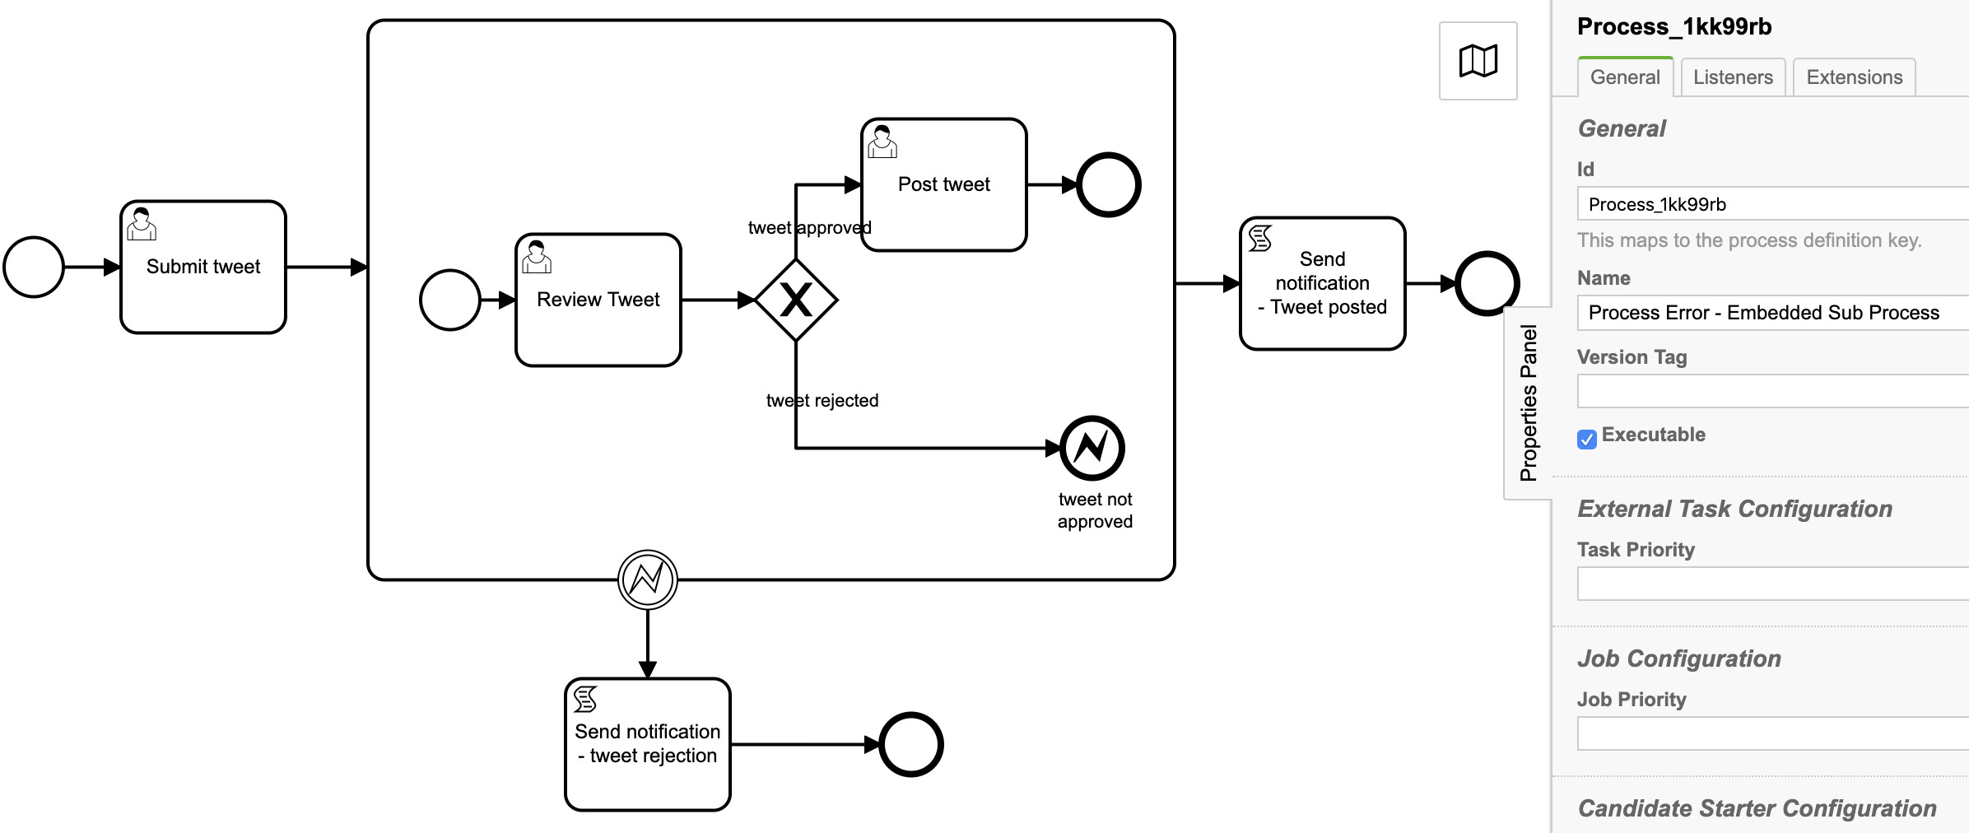

Id: Process_1kk99rb
Name: Process Error - Embedded Sub Process

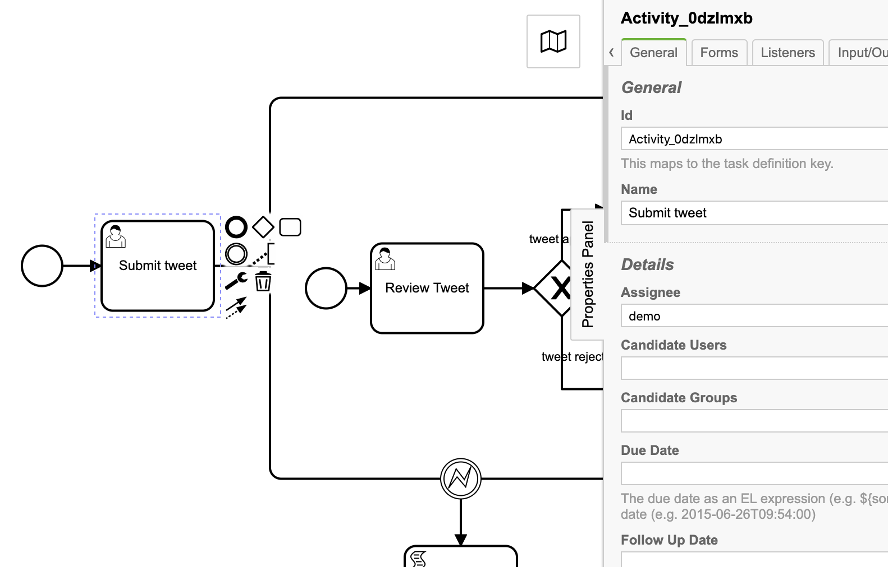
2. User task: Submit tweet
Id: Activity_0dzlmxb
Name: Submit tweet
Assignee: demo
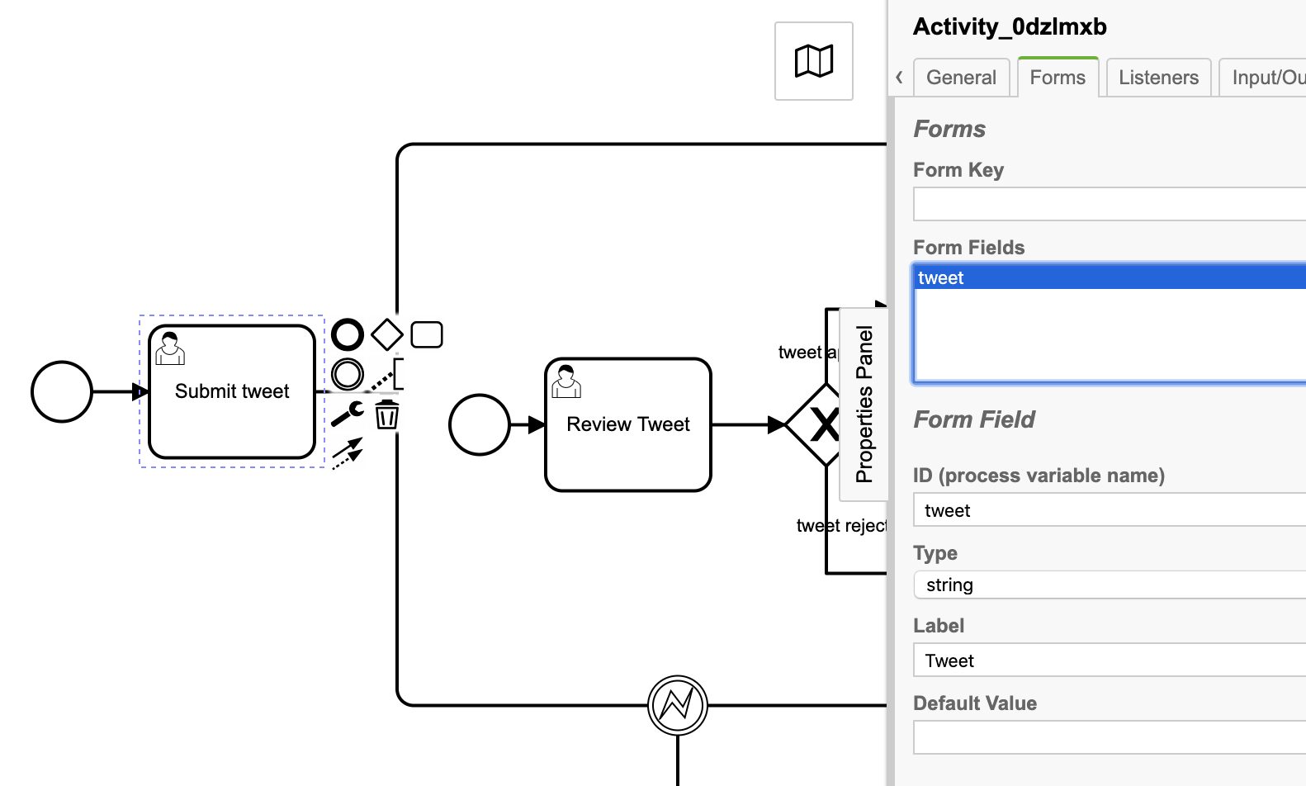
Task form:

3. User task: Review tweet
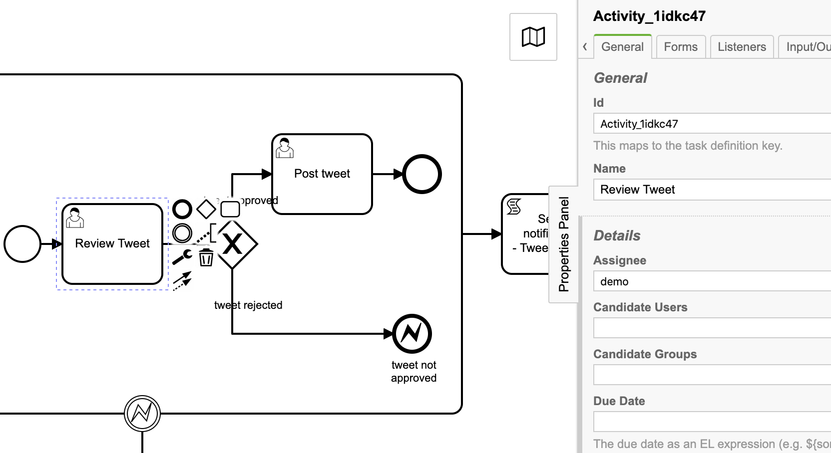
Id: Activity_1idkc47
Name: Review Tweet
Assignee: demo
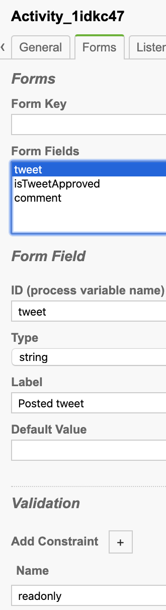
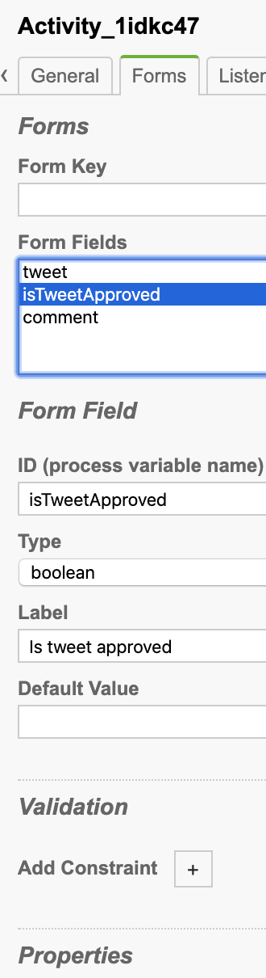
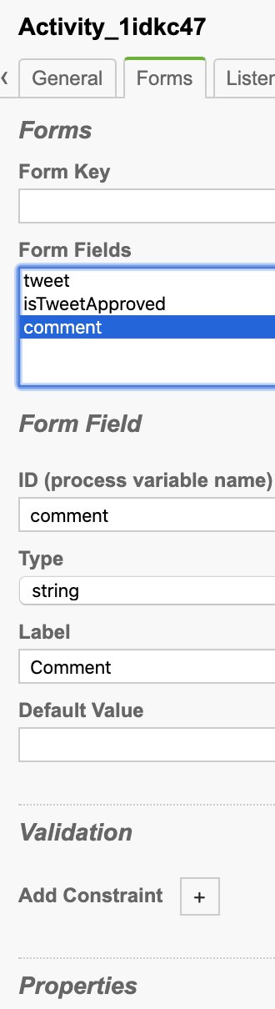
Task form:

4. Sequence flow constraint:

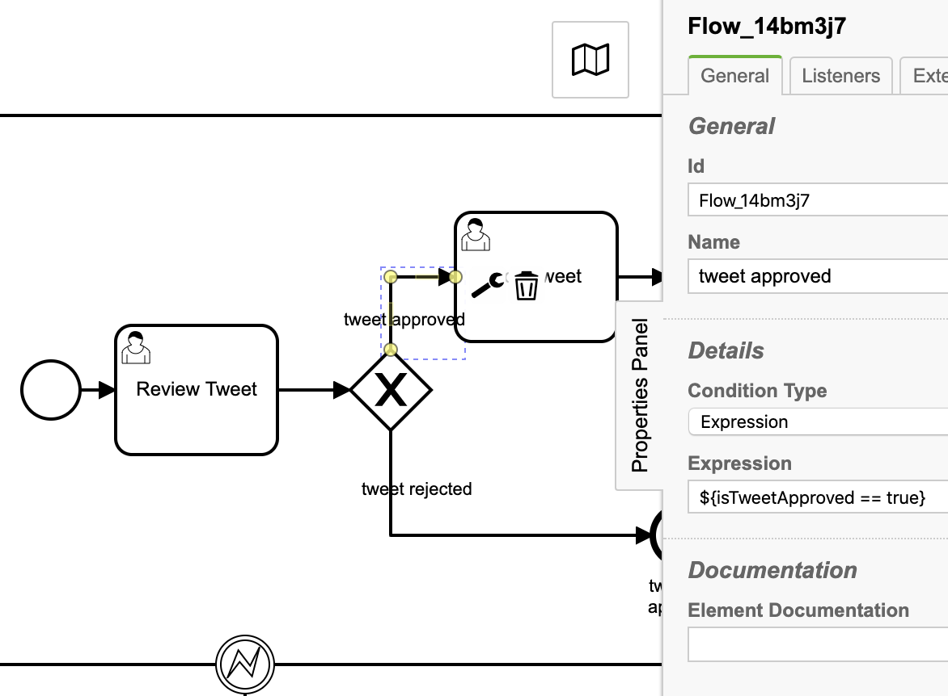
tweet approved

Id: Flow_14bm3j7
Name: tweet approved
Condition Type: Expression
Expression: ${isTweetApproved == true}

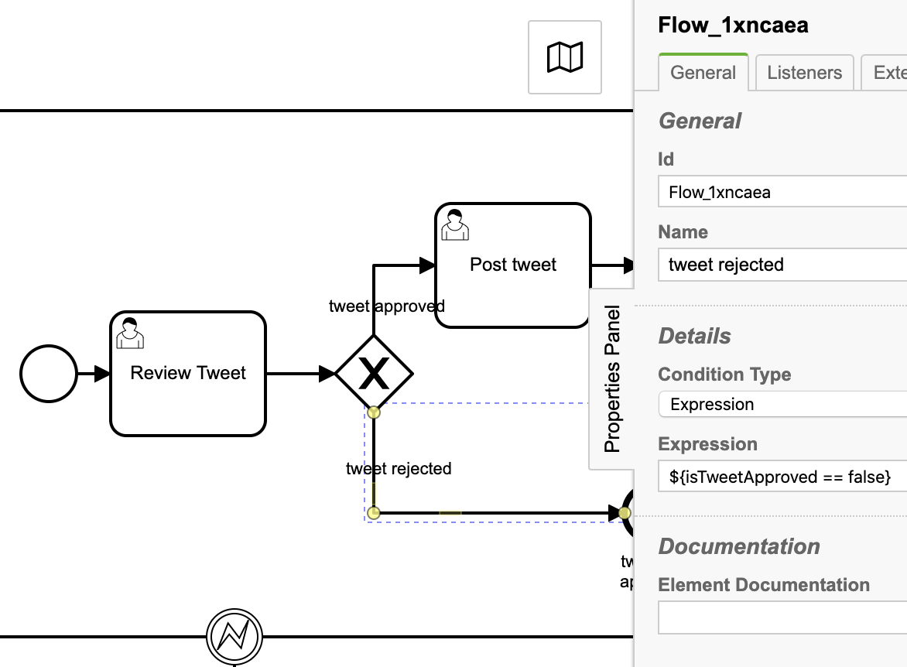
tweet rejected

Id: Flow_1xncaea
Name: tweet rejected
Condition Type: Expression
Expression: ${isTweetApproved == false}

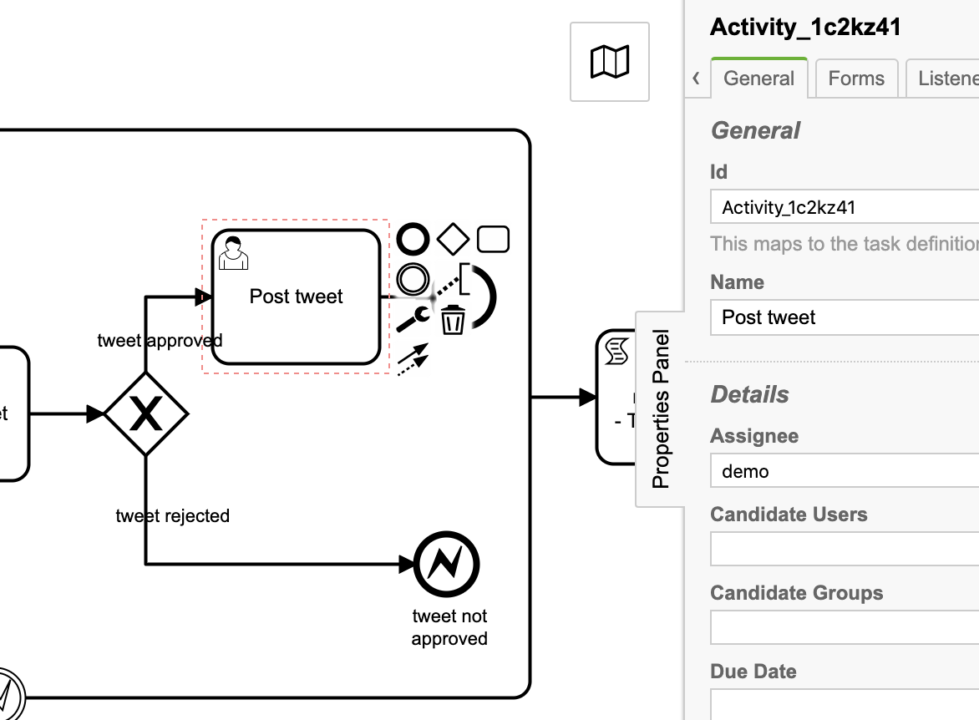
5. User task: Post tweet

Id: Activity_1c2kz41
Name: Post tweet
Assignee: demo

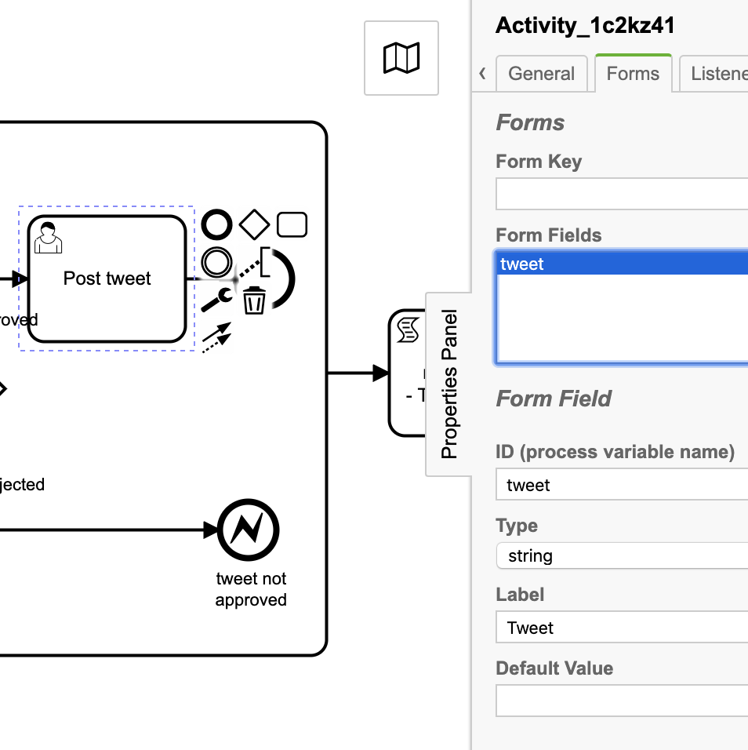
Task form:

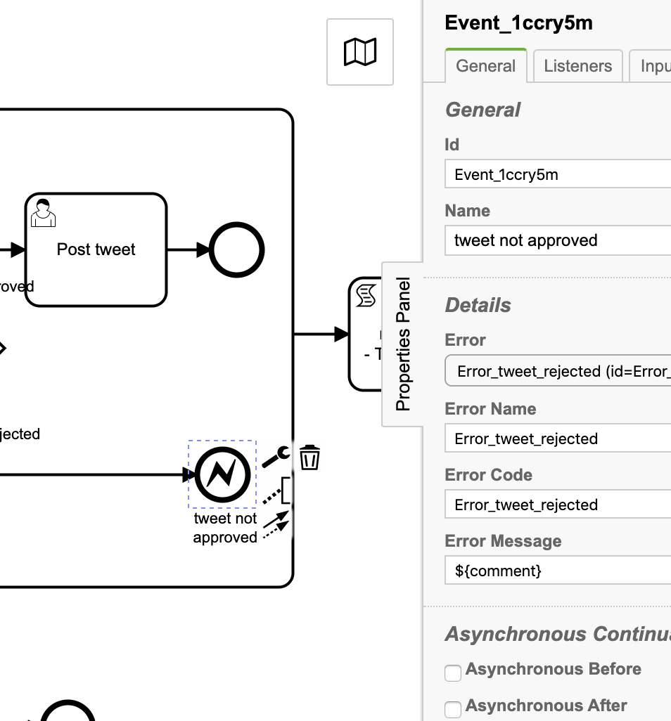
6. End error event: tweet not approved

Id: Event_1ccry5m
Name: tweet not approved
Error: Error_tweet_rejected (id=Error_0lb6uv1)
Error Name: Error_tweet_rejected
Error Code: Error_tweet_rejected
Error Message: ${comment}

6. Boundary end error event: tweet not approved
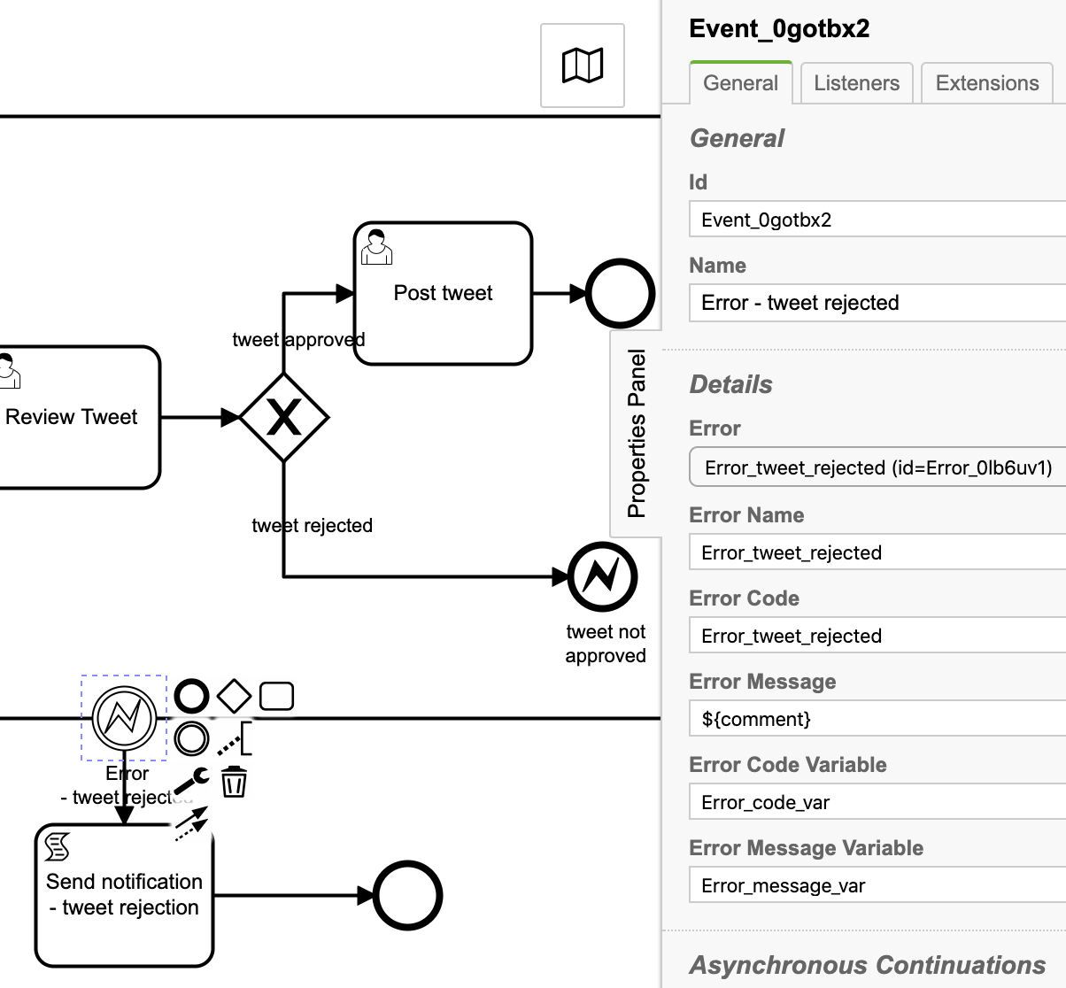

Id: Event_0gotbx2
Name: Error - tweet rejected
Error:
Error Name: Error_tweet_rejected
Error Code: Error_tweet_rejected
Error Message: ${comment}
Error Code Variable: Error_code_var
Error Message Variable: Error_message_var

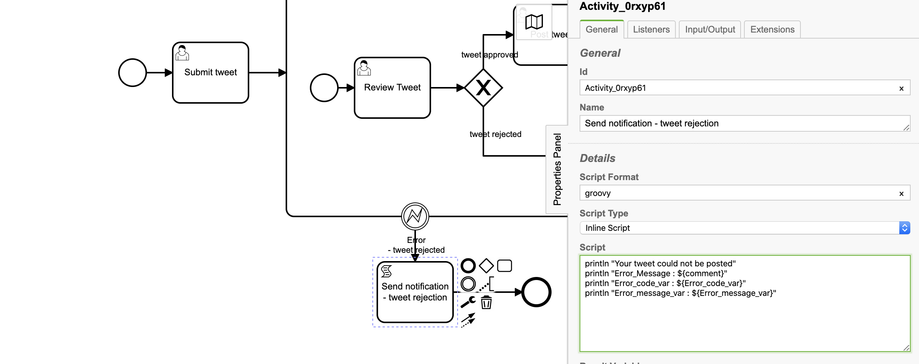
7. Script task: Send notification - tweet rejection

Id: Activity_0rxyp61
Name: Send notification - tweet rejection
Script Format: groovy
Script Type: Inline Script
Script:
println "Your tweet could not be posted"
println "Error_Message : ${comment}"
println "Error_code_var : ${Error_code_var}"
println "Error_message_var : ${Error_message_var}”

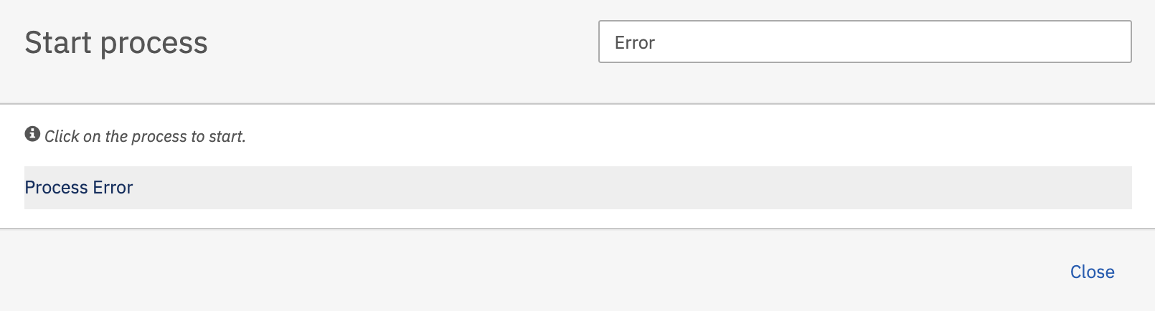
8. Deploy the process and start the process.

Hit the Process Error then hit the Start button.

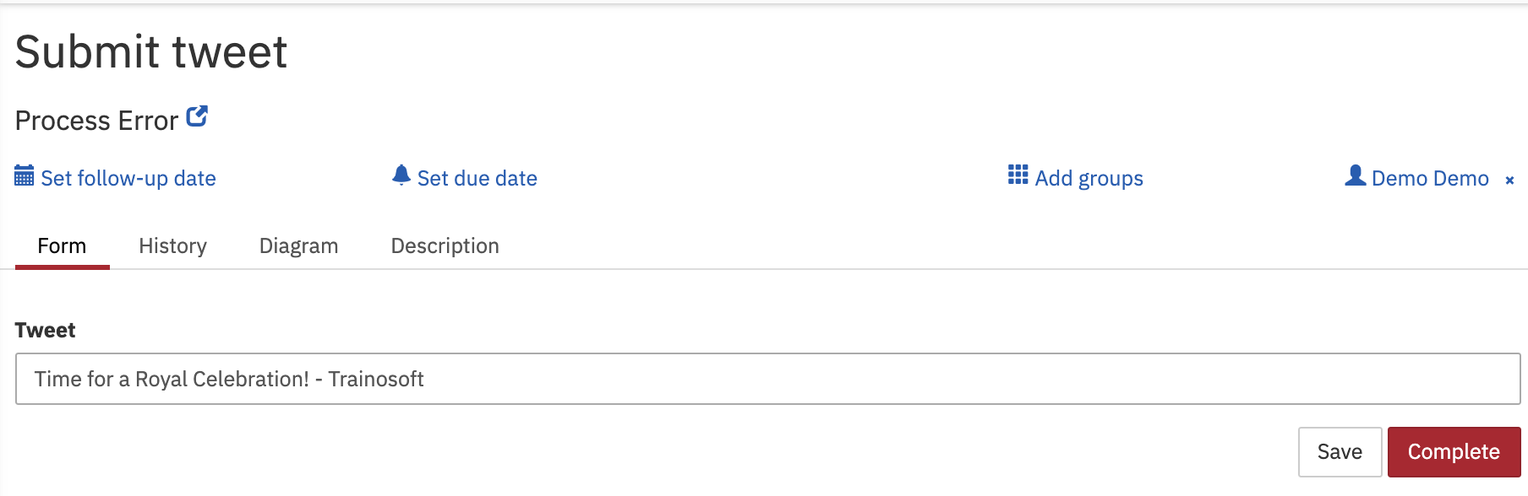
User task Submit tweet created as per process.

Hit the Complete button

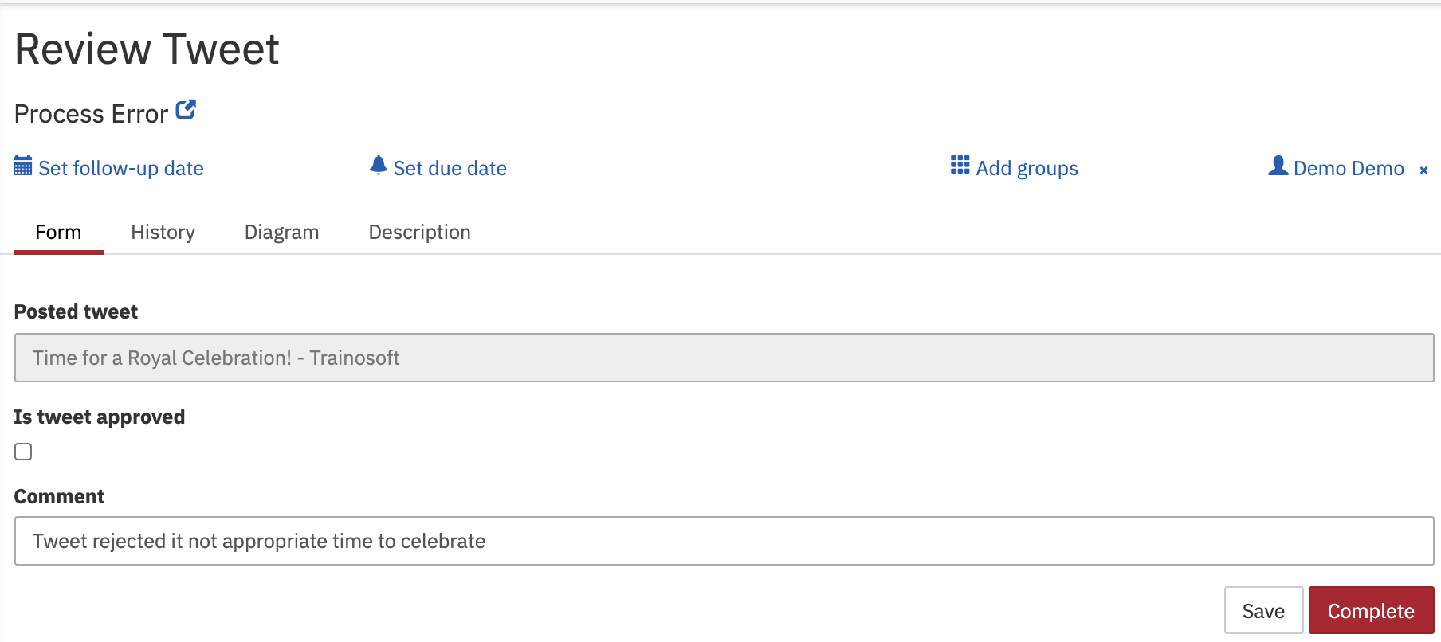
User task Review tweet created as per process.
Hit the Complete button

Observe the tomcat console output

Your tweet could not be posted
Error_Message : Comment rejected
Error_code_var : Error_tweet_rejected
Error_message_var : Comment rejected

So you can see once tweet review rejected, Error end event triggered and it is handler through error boundary event and notification will be sent through script task and then process instance is terminated.

Handle error thrown from service, script, listeners
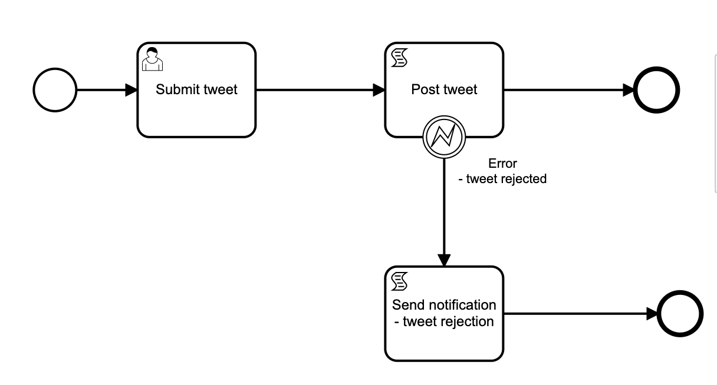
Throwing error:
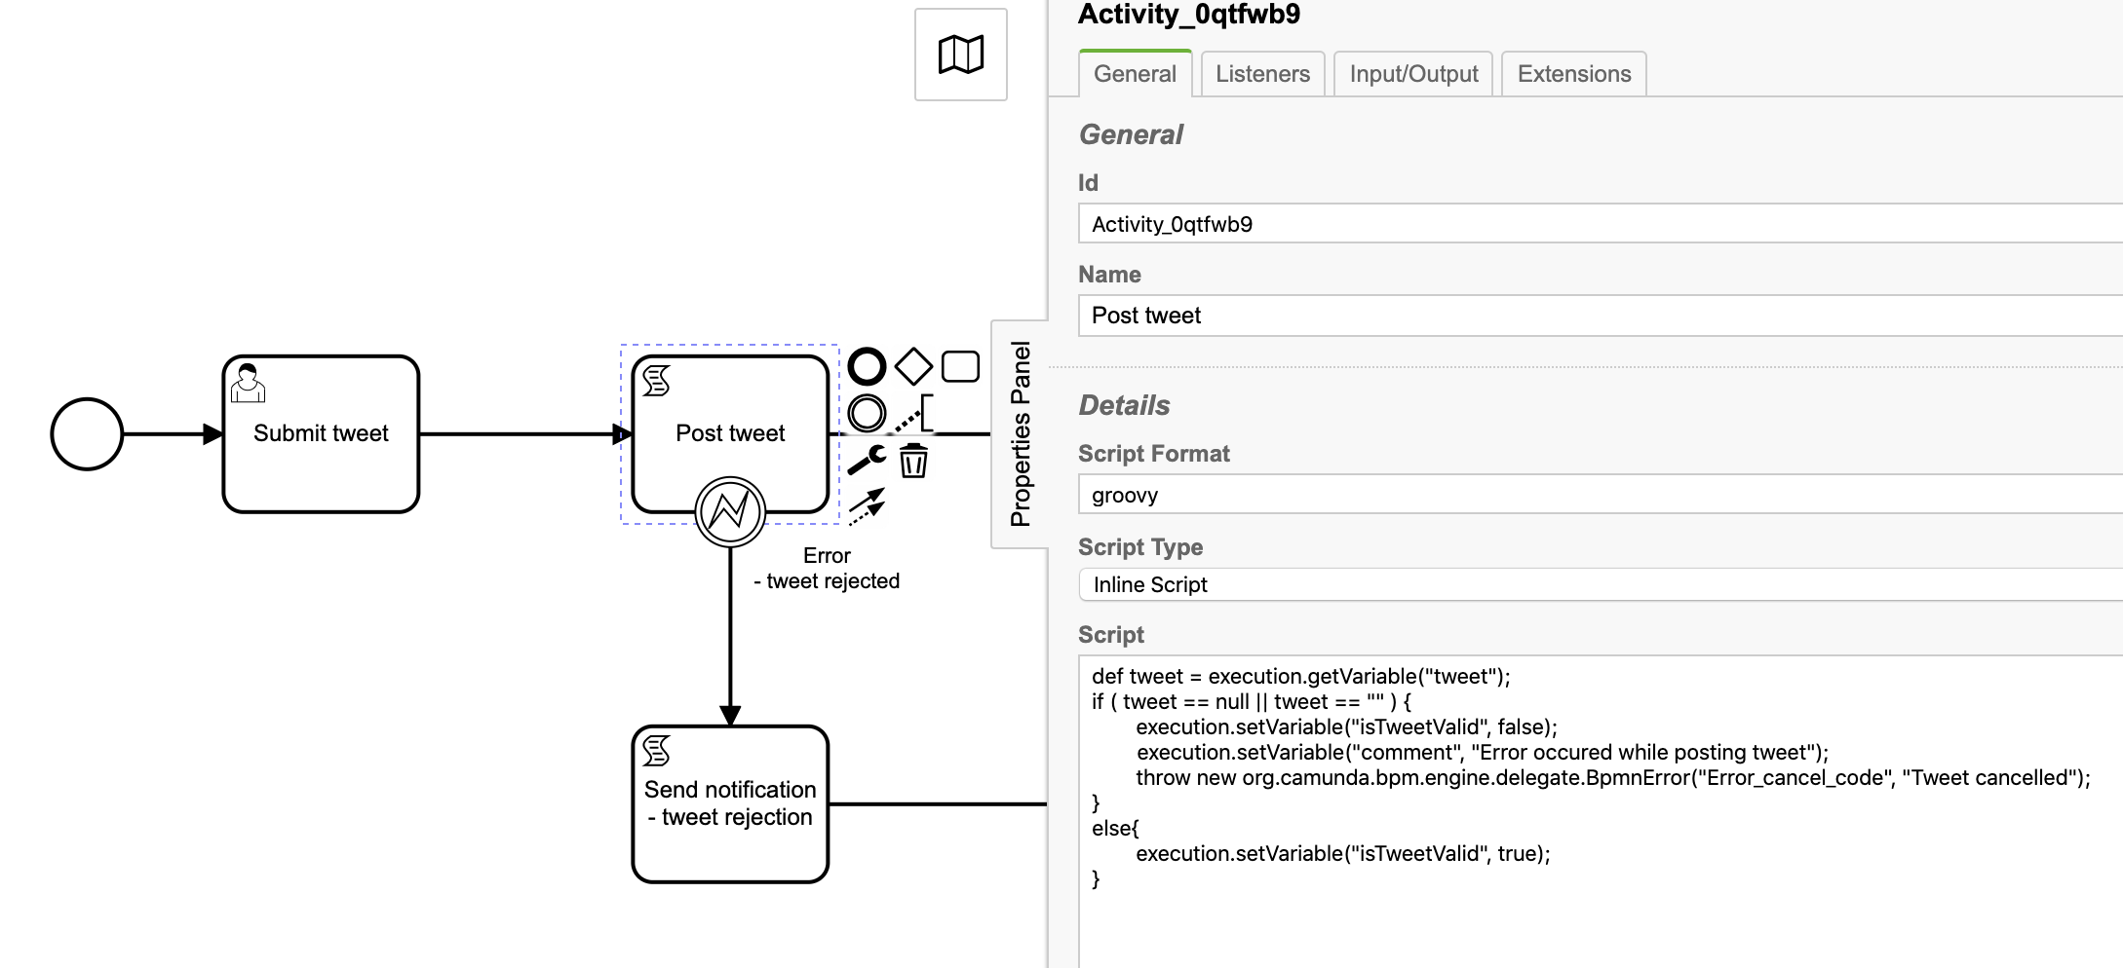

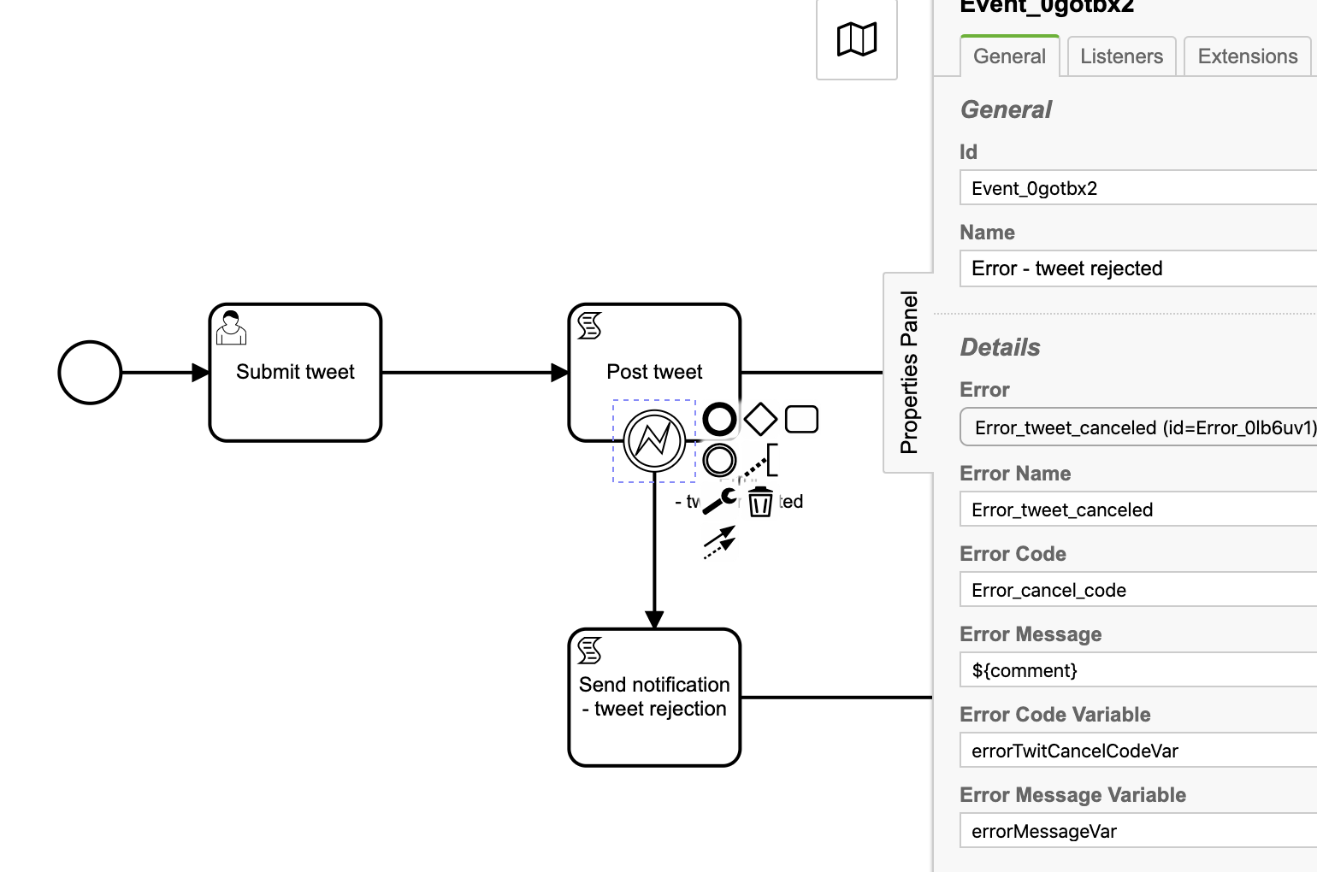
Boundary error event:

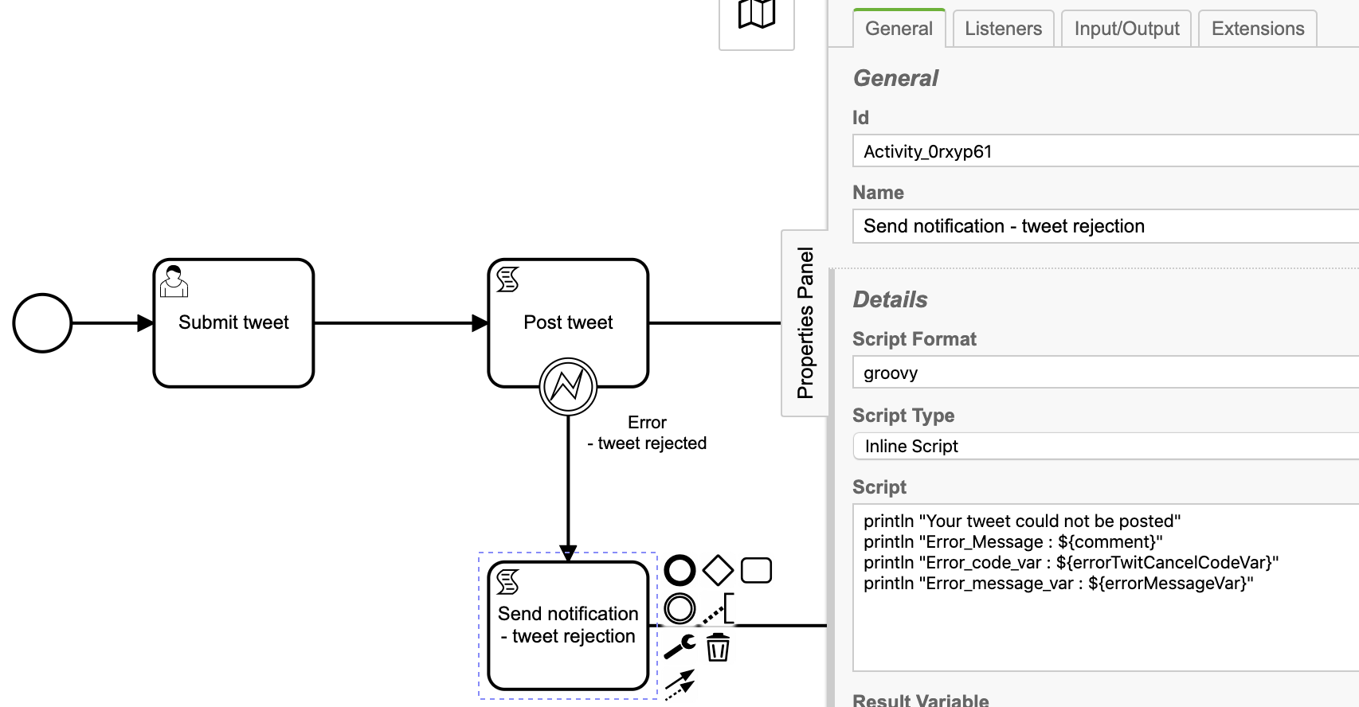
Handler error:

Script:
println "Your tweet could not be posted"
println "Error_Message : ${comment}"
println "Error_code_var : ${errorTwitCancelCodeVar}"
println "Error_message_var : ${errorMessageVar}”

Process output:
Leave tweet field empty so that error can be thrown.

Your tweet could not be posted
Error_Message : Error occured while posting tweet
Error_code_var : Error_cancel_code
Error_message_var : Tweet cancelled

